Treatment Tracker
Purpose: To provide valuable acceptance rate data for treatment diagnosed and presented to patients. This tracker will give percentage rates of acceptance as well as total dollar amounts of what was presented. It will breakdown areas that require improvement and training and also areas that the Drs/HYG and treatment consultants are excelling at. This will be completed by the treatment consultant presenting treatment daily, for each patient and reported to the office manager and Dr weekly with totals.

How To:
- Open treatment tracker excel spreadsheet in the shared drive
- Fill tracker in according to required data
  - Date
  - Patient name
  - $$ presented
  - $$ accepted per provider
  - Deposit amount
  - Hygienist seen that day
  - DR seen/who diagnosed the TX
  - Scheduled date
- Save the tracker
- Complete the above steps for every office consultation

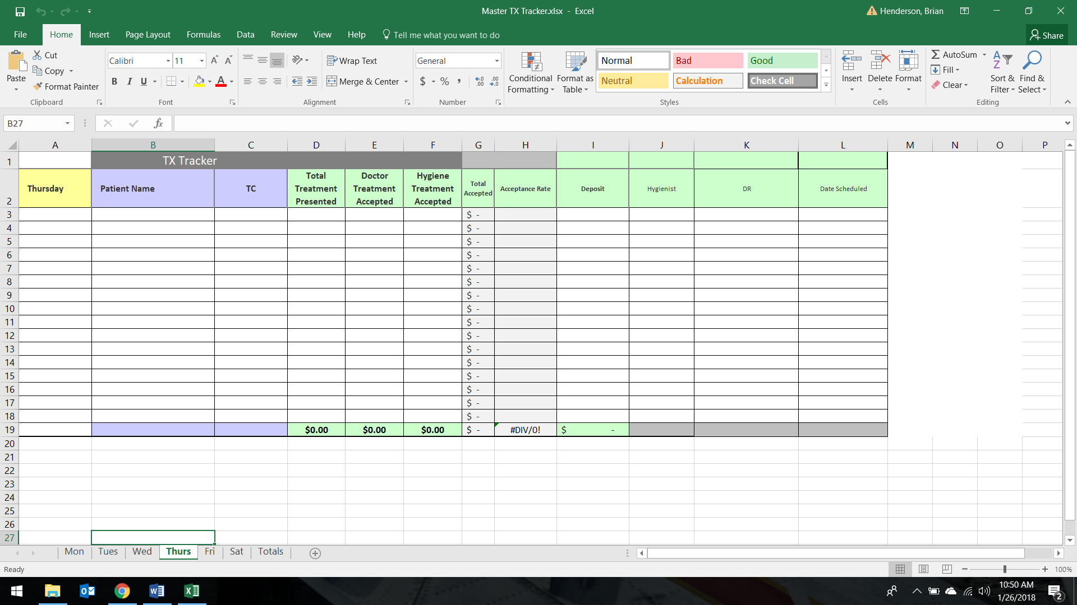
Treatment Tracker Follow Up
Purpose: To ensure that all of our patients are properly reminded of the treatment recommended for them; we are insistent on our patients maintaining proper dental health.

How: Utilizing the TX tracker to create follow up lists
2-2-2 Method
- Follow up with patients 2 days after they’ve been presented their treatment plan: “Good morning Joe! This is Tiffanie with Amazing Dental, just calling to touch base with you. Did you think of any questions after your appointment on Tuesday? Anything I can help answer?” --- “Fantastic, we have an appointment available next Wednesday at 8am, how does that time look for you?”; if they don’t schedule move onto the next step.
    - Put notes in the patient’s office journal – they should include: TX Plan follow up #1 as subject; notate – TX needed, discussion/reason not scheduled or the date the patient chose to schedule, any pertinent information from your call that can be useful to someone else/yourself at your next conversation with the patient.
- Follow up with patients 2 weeks after they’ve been presented their treatment plan: “Hello Joe! It’s Tiffanie with Amazing Dental, calling to check in with you. Dr Smith mentioned that he’d like to see you in for that crown, have you had a chance to look at your schedule? Are there any questions about the treatment that I can help answer for you?” --- “Fantastic, we have an appointment available next Wednesday at 8am, how does that time look for you?”; if they don’t schedule move onto the next step.
    - Put notes in the patient’s office journal – they should include: TX Plan follow up #1 as subject; notate – TX needed, discussion/reason not scheduled or the date the patient chose to schedule, any pertinent information from your call that can be useful to someone else/yourself at your next conversation with the patient.
- Follow up with patients 2 months after they’ve been presented their treatment plan: “Hello Joe! It’s Tiffanie with Amazing Dental, calling to check in with you. It’s been a few months since we’ve seen you and Dr Smith is getting concerned. He’d like to see you next week if you’re available. I have an appointment I can reserve with Dr Smith on Wednesday at 8am, does that work for your schedule?” --- If they don’t schedule, then you will touch base with the patient again at their 6 months HYG appointment.
    - Put notes in the patient’s office journal – they should include: TX Plan follow up #1 as subject; notate – TX needed, discussion/reason not scheduled or the date the patient chose to schedule, any pertinent information from your call that can be useful to someone else/yourself at your next conversation with the patient.

